***Materials and methods***

*Sample origination*

Samples included in the current study are a subset of mammary quarter milk samples collected during a longitudinal, cross-sectional study of 10 certified organic dairy farms in Vermont (US). The study was carried out in Winter 2019-2020. Participating farms milked an average of 69.5 cows (median: 70; range: 44-105) of various breeds. Five farms housed cows in a tiestall bedded with wood shavings, and 5 utilized a bedded pack system (3 actively managed for composting, 2 static). Three visits were completed at 8 farms, with 1 herd sampled twice and 1 herd sampled 4 times before interruption by the COVID-19 pandemic. On average, 33.6 days elapsed between sequential farm visits for each herd (median: 34; range: 27-43). From each herd, 35 lactating cows of varying parity in early- to mid-lactation were chosen at random to be repeatedly sampled for the duration of the study. Cows that were unable to be sampled at a follow-up visit (dried off, left the herd) were replaced with another lactating cow in the herd dictated by convenience. Around the time of the first farm visit, herd records were captured from the record processing center working with each of 9 participating herds (Lancaster DHIA, Manheim, PA; Dairy One Co-Op. Inc., Ithaca, NY) to obtain freshening date and parity for the current lactation. Freshening date and parity for 1 herd was obtained from personal communication with the producer who kept meticulous written records. At each farm visit, duplicate quarter milk samples were aseptically collected from each lactating quarter immediately before milking for all enrolled cows according to NMC guidelines (NMC, 2017). [Briefly, after routine pre-milking teat disinfection was completed, researchers scrubbed teat ends and the distal third of teats with 70% isopropyl alcohol-soaked gauze swabs until teat ends were visibly clean while wearing clean disposable gloves, discarded 3-5 squirts of foremilk, and collected approximately 5-6 mL of milk into sterile 11-mL flip-top vials.] Samples were kept on ice in a cooler during transport until stored temporarily at 4°C in the laboratory, where an aliquot was frozen for SCC measurement.

*SCC measurement*

Aliquots of frozen quartermilk samples were sent to the Vermont State Agricultural and Environmental Laboratory, where samples were thawed at time of processing and quarter-level somatic cell count was determined using flow cytometry (Somacount FC, Bentley Instruments).

*Aerobic culture of milk samples*

Standard aerobic bacteriological culture of milk samples was performed in duplicate within 24 hours of collection to identify the intramammary infection status of each quarter sampled. After being homogenized by gentle inversion, tryptic soy agar plates with 5% sheep blood (Northeast Laboratory, Waterville, ME) were inoculated with one loopful (approximately 10 μL) of milk using disposable plastic inoculating loops. Plates were then incubated in aerobic conditions at 37°C before being read at approximately 48 hrs. A quarter was considered positive for an IMI when greater than or equal to 1 CFU (100 CFU/mL) of a particular isolate was identified with the same morphology for both duplicate samples (interpretation in series; Dohoo et al., 2011). A quarter was considered negative when there was no significant growth on either duplicate plate (≤2 CFU on each plate; if growth on both duplicates, morphology of isolates on each plate distinct from one another). Interpretation of duplicate quartermilk samples in series results in decreased sensitivity but higher specificity for identifying NASM intramammary infections as compared to a single sample (Dohoo et al., 2011). This approach was chosen to maximize the specificity of culture to identify quarters as positive for a NASM IMI (i.e., minimize false positives), as collection of a large number of samples in the field under time pressure and occasionally with minimally trained personnel resulted in a moderately high rate of contamination (13%). Samples were classified as contaminated if more than 2 different morphologically-distinct isolates grew on a plate.

*Speciation of bacterial isolates*

Isolates deemed to be causing IMI were selected and grown in isolation on blood agar. Standard benchtop tests were done to presumptively identify bacteria following NMC procedure guidelines, including differential growth on selective media, colony morphology, hemolytic pattern, catalase reaction, Gram stain, and coagulase testing (NMC, 2017). Isolates were preserved in tryptic soy broth with a final concentration of 15% glycerol in cryovials and stored at -80°C. Frozen isolates were sent overnight on ice to the University of Missouri for speciation using MALDI-TOF mass spectrometry (Microflex, Bruker Daltonics) with Flex Control software (Bruker Daltonics). The protocol for identifying bacterial isolates with MALDI-TOF mass spectrometry has been described previously (Adkins et al., 2022). Generated spectra were assigned a score based on similarity with spectra in the manufacturer’s database, as well as the University of Missouri laboratory custom database (Adkins et al., 2018). The confidence levels used for species identification were applied as previously described (Cameron et al., 2017), in which ≥1.7 was used for staphylococcal and mammaliicoccal species-level identification and <1.7 was classified as inconclusive. Suspect NASM isolates unable to be identified to the species level and those identified as *Staphylococcus agnetis* or *Staphylococcus hyicus* by MALDI-TOF were speciated using *tuf*gene sequences with a cut-off of 98% identity as previously described (Hwang et al., 2011).

*Selection and description of data set*

The initial data set included 3,331 quarter observations where the bacteriological status of a quarter could be determined. Quarters were then selected that: 1) had an intramammary infection due to any *Staphylococcus* species (in pure culture) with ≥ 5 associated observations *or* was culture negative; 2) was collected from a cow ≤ 305 days in milk at time of observation; 3) had an associated quarter-level somatic cell count measurement (Figure 1)*.* [The final data set of 2,260 observations came from 1,272 quarters of 360 cows across the 10 herds included in the field study. The mean (median; range) number of cows included per herd was 36 (36; 34-39), whereas the number of quarters sampled per cow was 3.5 (2; 1-4). The mean number of observations per quarter included was 2.1 (2; 1-4). The average time elapsed between sequential observations of a quarter was 37.1 days (median: 34.5; SD: 11.6), with an overall range of 27-96 days. Does this belong in Results?]

*Statistical analysis*

Quarter somatic cell counts, intramammary infection status, cow parity and days in milk data were organized into a spreadsheet (Microsoft Excel, Redmond, WA) and imported into the R Statistical Programming Environment (R Development Core Team, 2023) for analysis. Raw quarter-level somatic cell count was converted to somatic cell score [log2(quarter somatic cell count/1000) + 3] in order to address the non-normal distribution of SCC data.

A linear mixed-effects model was fitted to the data set in order to compare somatic cell scores associated with quarters identified to have single-pathogen intramammary infections with a given *Staphylococcus* species to culture negative quarters. The “lme” function of the “nlme” package was used to build this model, in which the somatic cell score for each quarter observation was the outcome variable, and *Staph.* species causing IMI (with culture negative quarters as the reference value) was the fixed predictor variable. The number of days in milk at time of sampling was included in the fixed part of the model to adjust the estimates of the *Staph.* species and quarter SCS association for confounding by this variable. The hierarchical structure of the data was addressed by fitting random intercepts for quarter, cow, and herd (observations nested within quarter, quarters nested within cow, and cow within herd). Samples collected at different time points for a given quarter were considered repeated measurements, and a spatial exponential correlation structure was used to account for the correlation between multiple milk samples collected from the same quarter. Best way to say we are essentially ignoring the time between observations (~30 days), as it’s so short? The model was:

SCS*ijkl* = β0 + β1 *Staph.* species*ijkl* + β2DIM*ijkl* + β3DIM*ijkl*2 + β4DIM*ijkl*3 + v*l* + u*kl* + w*jkl* + e*ijkl*,

where SCS*ijkl* is the predicted somatic cell score for the *i*th sample of the *j*th quarter of the *k*th cow from the *l*th herd; β0 is the intercept; β1, β2, β3, and β4 are the regression coefficients for *Staph.* species, DIM as a cubic term (to correct for the nonlinear relationship between DIM and SCS); and *vl*, *ukl*, *wjkl*, and *eijkl*are the herd random effect, cow random effect, quarter repeated effect, and sample error term, respectively (approximate normal distribution assumed). Biologically plausible interactions were investigated between IMI status, SCS, and parity variables. Statistical significance for fixed effects and interaction terms was declared at P ≤ 0.05 for Wald chi-squared tests. Final model fit was assessed by checking the homoscedasticity and normality of residuals (graphing of residuals vs. predicted values and Q-Q plots, respectively).

***Results***

The final data set consisted of 2,260 observations: 648 quarters with an intramammary infection due to 10 different *Staph.* sp. (each with at least 5 associated observations), and 1,972 culture negative quarters. Observations included in the final data set came from 1,272 quarters of 360 cows across all 10 herds included in the field study. The mean (median; range) number of cows included per herd was 36 (36; 34-39), whereas the number of quarters sampled per cow was 3.5 (2; 1-4). The mean number of observations per quarter included was 2.1 (2; 1-4). Twenty-seven percent of observations were the sole observation contributed to the data set by a given quarter, 41% came from quarters contributing two time points, and 31% and 1% came from quarters contributing 3 and 4 observations, respectively. The average time elapsed between sequential observations of a quarter was 37.1 days (median: 34.5; SD: 11.6), with an overall range of 27-96 days. *Some* of this redundant with M and M but not all] *Staph. chromogenes* was the most commonly-found species (59% of IMI quarter observations; Figure 2), followed by *Staph. aureus* (17%)*, Staph. haemolyticus* (6%)*,* and *Staph. simulans* (5%)*.* A large amount of variability was observed in the somatic cell score for culture negative quarters and those infected with a number of different *Staph.* species, especially *S. chromogenes* and *S. aureus* (observed data presented; Figure 2).

The final model comparing somatic cell scores of quarters infected with *Staphylococcus* species to culture negative quarters adjusted for days in milk is presented in Table 1. Somatic cell score was significantly higher in quarters infected with *S. agnetis, S. aureus, S. chromogenes, S. devriesei, S. haemolyticus, S, hyicus, S. simulans, S. warneri, and S. xylosus* than uninfected negative control quarters (P ≤ 0.05; Table 1). The interaction between IMI status and DIM was not significant (P = 0.42). [The effect of parity on SCS was visualized using the raw data, and SCS appeared to have a positive linear relationship with parity. When SCS was plotted as function of IMI status by parity using the raw data, most bacterial species (with the exception of *S. hyicus,* n = 6 observations) had a relatively constant effect on SCS regardless of parity.] A model with an interaction term between IMI status and parity found that the interaction between IMI status and parity was not significant (P = 0.86), but parity and bacterial species separately were both significant predictors of SCS (P < 0.0001). A model was attempted with a three-way interaction term between DIM (3-degree polynomial term), IMI status, and parity, but would not converge due to complete data separation. An additive model with DIM (3-degree polynomial term), IMI status, and parity found all three variables to be statistically significant (P < 0.0001) predictors of SCS. When compared to the model with only DIM and IMI status, the model including parity changed the coefficients for each *Staph.* sp. group by ≤ 5%, and standard errors by ≤ 1%. As the effect of parity was the same across all groups of IMI status, and the impact of its inclusion was minimal on the coefficients of the variable of interest, only results from the model including DIM (3-degree polynomial term) and IMI status on quarter SCS are presented in the interest of simplicity.

Least square means estimates of quarter somatic cell scores across DIM for the ten different *Staph*. species modeled as compared to culture negative quarters are presented in Figure 3. Estimates for each species are only presented for the observed range of days in milk. Infection by most *Staph.* species elevated quarter SCS notably above the SCS for no growth quarters (Figure 3).

Predicted raw somatic cell counts for quarters infected with different *Staph.* species at 91 days in milk are presented in Table 2. The highest cell count was for quarters infected with *S. warneri,* followed by *S. aureus, S. agnetis,* and *S. hyicus* (Table 2)*.* Intramammary infection with the most commonly-found species, *S. chromogenes,* resulted in a quarter somatic cell score of 80,376 cells/mL for a cow 91 days in milk (Table 2).

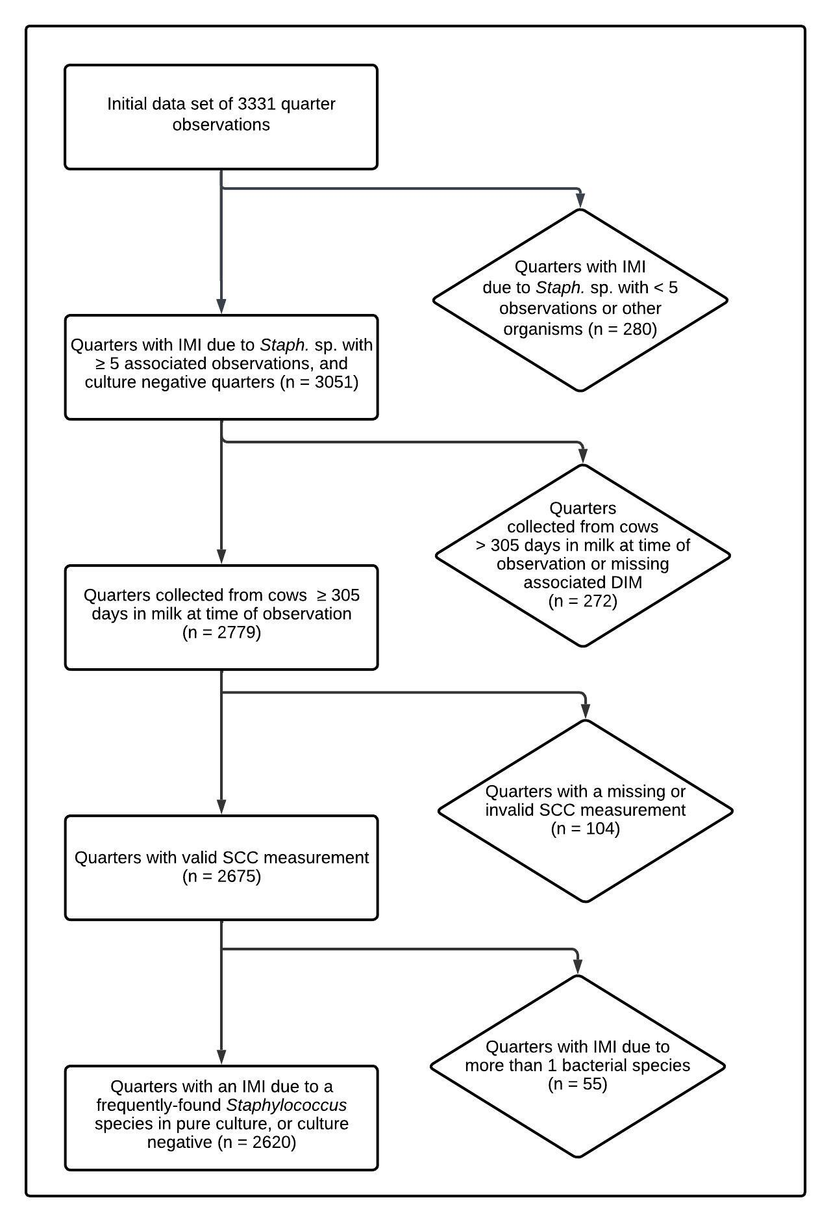

Figure 1.Flow diagram describing selection of final data set.

|  |  |  |  |
| --- | --- | --- | --- |
| Table 1. Final multivariable model describing the effect of intramammary infection with frequently-isolated *Staphylococcus* species on quarter somatic cell score, adjusted for days in milk at time of sampling. [Do we like the asterisks? If so, which column? These p-values are not adjusted for multiple comparisons] | | | |
| *Staphylococcus* sp. | No. quarter observations | Coefficient estimate (SE) | *P*-value |
| Intercept | - | -0.03 (0.29) | 0.90 |
| No growth | 1972 | *Reference* | *Reference* |
| *S. agnetis\** | 21 | 3.76 (0.45) | <0.00001 |
| *S. aureus\** | 112 | 4.81 (0.22) | <0.00001 |
| *S. chromogenes\** | 384 | 2.88 (0.12) | <0.00001 |
| *S. devriesei\** | 15 | 1.62 (0.54) | 0.003 |
| *S. equorum* | 9 | 0.12 (0.48) | 0.81 |
| *S. haemolyticus\** | 40 | 1.77 (0.31) | <0.00001 |
| *S. hyicus\** | 6 | 3.23 (0.85) | 0.0001 |
| *S. simulans\** | 35 | 3.11 (0.39) | <0.00001 |
| *S. warneri\** | 15 | 5.18 (0.60) | <0.00001 |
| *S. xylosus\** | 11 | 2.96 (0.62) | <0.00001 |
| Days in milk | - | -0.003 (0.01) | 0.54 |
| Days in milk2 | - | 0.00001 (0.00004) | 0.73 |
| Days in milk3 | - | <0.00001 (<0.00001) | 0.53 |
| * Quarter somatic cell score differs from negative controls (P ≤ 0.05) | | | |

|  |  |  |  |
| --- | --- | --- | --- |
| Table 1. Final multivariable model describing the effect of intramammary infection with frequently-isolated *Staphylococcus* species on quarter somatic cell score, adjusted for days in milk at time of sampling. [P-values from emmeans/contrast/adjusted for multiple comparisons, difference from no growth] | | | |
| *Staphylococcus* sp. | No. quarter observations | Coefficient estimate (SE) | *P*-value |
| Intercept | - | -0.03 (0.29) | 0.90 |
| No growth | 1972 | *Reference* | *Reference* |
| *S. agnetis\** | 21 | 3.76 (0.45) | <0.00001 |
| *S. aureus\** | 112 | 4.81 (0.22) | <0.00001 |
| *S. chromogenes\** | 384 | 2.88 (0.12) | <0.00001 |
| *S. devriesei* | 15 | 1.62 (0.54) | 0.10 |
| *S. equorum* | 9 | 0.12 (0.48) | 1.00 |
| *S. haemolyticus\** | 40 | 1.77 (0.31) | <0.00001 |
| *S. hyicus\** | 6 | 3.23 (0.85) | 0.007 |
| *S. simulans\** | 35 | 3.11 (0.39) | <0.00001 |
| *S. warneri\** | 15 | 5.18 (0.60) | <0.00001 |
| *S. xylosus\** | 11 | 2.96 (0.62) | <0.0001 |
| Days in milk | - | -0.003 (0.01) | 0.54 |
| Days in milk2 | - | 0.00001 (0.00004) | 0.73 |
| Days in milk3 | - | <0.00001 (<0.00001) | 0.53 |
| * Quarter somatic cell score differs from negative controls (P ≤ 0.05, adjusted for multiple comparisons using the Tukey-Kramer procedure). | | | |

|  |  |  |
| --- | --- | --- |
| Table 2. Estimated quarter somatic cell count by intramammary infection status at 91 days in milk (13 weeks) for frequently-isolated *Staphylococcus* species and culture negative quarters. [which one we like better?] | | |
| *Staphylococcus* sp. | Estimated quarter somatic cell count (cells/mL) | 95% lower and upper confidence level (cells/mL) |
| No growth | 10,927 | 8,056 - 14,822 |
| *S. agnetis* | 148,437 | 69,021 - 319,232 |
| *S. aureus* | 307,101 | 197,323 - 477,951 |
| *S. chromogenes* | 80,376 | 56,942 - 113,454 |
| *S. devriesei* | 33,513 | 13,597 - 82,599 |
| *S. equorum* | 11,855 | 5,292 - 26,556 |
| *S. haemolyticus* | 37,333 | 21,217 - 65,688 |
| *S. hyicus* | 102,478 | 26,368 - 398,281 |
| *S. simulans* | 94,617 | 48,346 - 185,175 |
| *S. warneri* | 395,190 | 148,189 - 1,053,891 |
| *S. xylosus* | 84,985 | 30,798 - 234,512 |

|  |  |  |  |
| --- | --- | --- | --- |
| Table 2. Estimated raw quarter somatic cell count by intramammary infection status at 91 days in milk (13 weeks) for frequently-isolated *Staphylococcus* species and culture-negative quarters. [which one we like better?] | | | |
| *Staphylococcus* sp. | Estimated quarter somatic cell count (× 1,000 cells/mL) | 95% lower confidence level (× 1,000 cells/mL) | 95% upper confidence level (× 1,000 cells/mL) |
| No growth | 10.9 | 8.1 | 14.8 |
| *S. agnetis* | 148.4 | 69 | 319.2 |
| *S. aureus* | 307.1 | 197.3 | 478 |
| *S. chromogenes* | 80.4 | 56.9 | 113.5 |
| *S. devriesei* | 33.5 | 13.6 | 82.6 |
| *S. equorum* | 11.9 | 5.3 | 26.6 |
| *S. haemolyticus* | 37.3 | 21.2 | 65.7 |
| *S. hyicus* | 102.5 | 26.4 | 398.3 |
| *S. simulans* | 94.6 | 48.3 | 185.2 |
| *S. warneri* | 395.2 | 148.2 | 1,053.9 |
| *S. xylosus* | 85 | 30.8 | 234.5 |

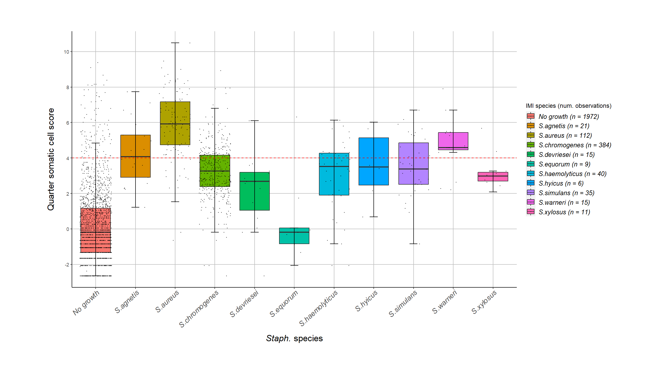

Figure 2. Somatic cell score for quarters with an intramammary infection due to *Staphylococcus* species and culture negative control quarters. The red dotted line is at a somatic cell score of 4. The observed data are displayed (i.e., quarters that were repeatedly positive for the same species contributed with several SCC measurements). Each box contains 50% of the data for a species, the median (line), and is bounded by the 25th and 75th percentiles. The upper whisker represents the largest observation less than or equal to the 75th quartile plus 1.5 times the interquartile range, while the lower whisker represents the smallest observation greater than or equal to the 25th quartile minus 1.5 times the interquartile range.

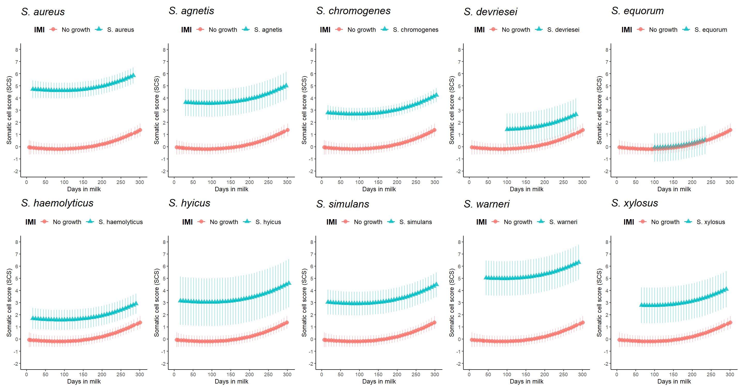

Figure 3. Quarter somatic cell score least square means estimates as a function of *Staph.* species IMI and days in milk, compared to culture negative quarters. Model estimates for each species are only presented for the range of days in milk found in the actual data set. Error bars represent the 95% confidence interval. [Is this true?]

Adkins, P. R. F., S. Dufour, J. N. Spain, M. J. Calcutt, T. J. Reilly, G. C. Stewart, and J. R. Middleton. 2018. Molecular characterization of non-aureus Staphylococcus spp. from heifer intramammary infections and body sites. J. Dairy Sci. 101(6):5388-5403.

Adkins, P. R. F., L. M. Placheta, M. R. Borchers, J. M. Bewley, and J. R. Middleton. 2022. Distribution of staphylococcal and mammaliicoccal species from compost-bedded pack or sand-bedded freestall dairy farms. J Dairy Sci 105(7):6261-6270.

Cameron, M., H. W. Barkema, J. De Buck, S. De Vliegher, M. Chaffer, J. Lewis, and G. P. Keefe. 2017. Identification of bovine-associated coagulase-negative staphylococci by matrix-assisted laser desorption/ionization time-of-flight mass spectrometry using a direct transfer protocol. J. Dairy Sci. 100(3):2137-2147.

Dohoo, I., S. Andersen, R. Dingwell, K. Hand, D. Kelton, K. Leslie, Y. Schukken, and S. Godden. 2011. Diagnosing intramammary infections: Comparison of multiple versus single quarter milk samples for the identification of intramammary infections in lactating dairy cows. J. Dairy Sci. 94(11):5515-5522.

Hwang, S. M., M. S. Kim, K. U. Park, J. Song, and E. C. Kim. 2011. Tuf gene sequence analysis has greater discriminatory power than 16S rRNA sequence analysis in identification of clinical isolates of coagulase-negative staphylococci. J Clin Microbiol 49(12):4142-4149.

National Mastitis Council. 2017. Laboratory Handbook on Bovine Mastitis. Third ed. National Mastitis Council, Inc., New Prague, MI.

R Development Core Team. 2023. R: A Language and Environment for Statistical Computing. R Foundation for Statistical Computing, Vienna, Austria.